Title: CEH v13 Ultimate Exam Study Guide
Subject: Full CEH v13 Curriculum (Modules 1–20)
Topics:
- Ethical Hacking Overview & Laws
- Reconnaissance (Footprinting & Scanning)
- Attack Phases (Enumeration, Vulnerability Analysis, System Hacking)
- Threat Vectors (Malware, Sniffing, Social Engineering, DoS)
- Specialized Hacking (Web, SQLi, Wireless, Mobile, IoT, Cloud)
- Defensive Controls & Cryptography
Summary: This study guide provides a condensed overview of the entire Certified Ethical Hacker v13 body of knowledge. It transitions from initial reconnaissance and scanning through exploitation of systems and web applications, ending with emerging threats in IoT/Cloud and the foundational mathematics of cryptography.
Key Concepts:
- Modules 1-5 (The Prep Phase): Focuses on the "Rules of Engagement," legal frameworks (HIPAA, SOX, GDPR), and the technical art of gathering intel. Footprinting involves OSINT, while Scanning and Enumeration move into active interaction with targets to find open ports and specific service versions.
- Module 6 (System Hacking): The "Meat" of the exam. Covers the CEH Hacking Methodology: Gaining Access, Escalating Privileges, Maintaining Access, and Clearing Logs. You must know buffer overflows, steganography, and rootkit types.
- Modules 7-12 (Network Threats): Covers malware components (droppers, crypters), sniffing (MITM attacks), and DoS/DDoS techniques. A major focus is placed on Module 12: Evasion, where you learn to bypass IDS, Firewalls, and Honeypots using fragmentation and obfuscation.
- Modules 13-15 (Web & Databases): Focuses on the OWASP Top 10. You must distinguish between XSS (Cross-Site Scripting), CSRF (Cross-Site Request Forgery), and various SQL Injection types (In-band, Out-of-band, Inferential/Blind).
- Modules 16-19 (Modern Targets): Examines Wireless (WPA3, KRACK), Mobile (Android/iOS rooting), IoT (hardware protocols), and Cloud (Shared Responsibility Model, Container security).
- Module 20 (Cryptography): Foundational math. Know the difference between symmetric (AES) and asymmetric (RSA) encryption, digital signatures, and PKI components.
Vocabulary List:
- OSINT (Open Source Intelligence): Gathering data from publicly available sources (Google Dorks, WHOIS, Shodan).
- Banner Grabbing: Determining the version of a service by reading its initial response string.
- Privilege Escalation: Increasing user rights (Vertical: User to Admin; Horizontal: User to User).
- APT (Advanced Persistent Threat): Long-term, sophisticated hacking campaigns, usually state-sponsored.
- SQL Injection (SQLi): Inserting malicious SQL queries into input fields to manipulate backend databases.
- Salting: Adding random data to a password before hashing to prevent Rainbow Table attacks.
- Dread/Stride: Risk assessment and threat modeling frameworks used in Vulnerability Analysis.

Five Phases of the EC-Council Hacking Methodology
The EC-Council hacking methodology provides a structured, ethical, and systematic approach to penetration testing. It is a core concept in the CEH (Certified Ethical Hacker) curriculum and helps security professionals understand how attackers think and operate.

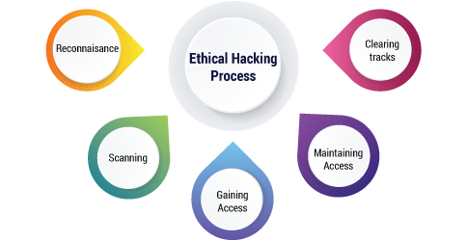

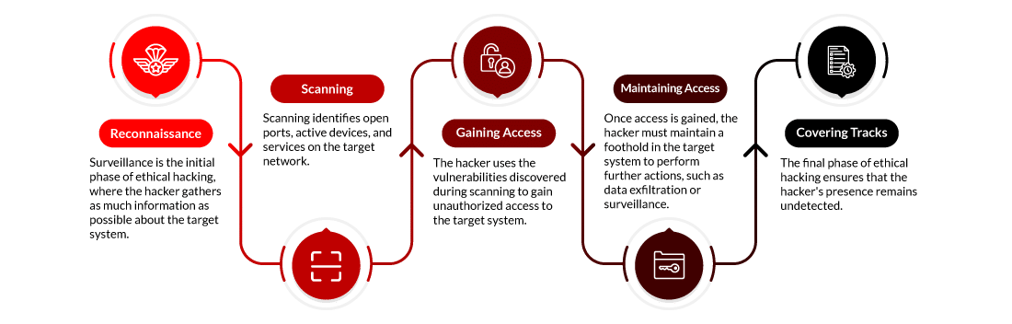

Overview of the Five Phases
Reconnaissance → Scanning → Gaining Access → Maintaining Access → Clearing Tracks

1. Reconnaissance (Footprinting)
Goal:
To gather maximum information about the target system, organization, or network.
Key Activities:
- OSINT (Open Source Intelligence)
- Domain and DNS information gathering
- Subdomain enumeration
- Social media profiling
Tools & Techniques:
- Google Dorks
- theHarvester
- WHOIS
- nslookup, dig
Nature:
- Mostly passive (no direct interaction with target)

2. Scanning
Goal:
To identify live hosts, open ports, running services, operating systems, and vulnerabilities.
Key Activities:
- Host discovery
- Port scanning
- Service and OS detection
- Vulnerability scanning
Tools & Techniques:
- Nmap
- Nessus
- OpenVAS
Nature:
- Active (direct interaction with target)

3. Gaining Access
Goal:
To exploit identified vulnerabilities and gain unauthorized access to the system.
Key Activities:
- Password attacks
- Web application attacks (SQL Injection, XSS)
- Exploitation of misconfigurations
Tools & Techniques:
- Metasploit
- SQLmap
- Hydra
- John the Ripper
Nature:
- Active exploitation phase

4. Maintaining Access
Goal:
To maintain persistent access to the compromised system for future use.
Key Activities:
- Installing backdoors
- Privilege escalation
- Creating hidden user accounts
Tools & Techniques:
- Backdoor scripts
- Scheduled tasks
Nature:
- Active persistence phase

5. Clearing Tracks
Goal:
To remove evidence of the attack and avoid detection.
Key Activities:
- Deleting or modifying logs
- Clearing command history
- Timestamp manipulation
Tools & Techniques:
- Log cleaners
- Manual log editing
Nature:
- Stealth and evasion phase

Summary Table

Phase | Purpose | Nature
Reconnaissance | Information gathering | Passive / Active
Scanning | Identify weaknesses | Active
Gaining Access | Exploitation | Active
Maintaining Access | Persistence | Active
Clearing Tracks | Hide evidence | Active

Memory Trick
R – Reconnaissance
S – Scanning
G – Gaining Access
M – Maintaining Access
C – Clearing Tracks

